**Report: act_report**

I received the opportunity via a Data Analyst program to gather, assess, clean and analyze the tweet archive from a Twitter home page called WeRateDogs. WeRateDogs is a Twitter account that rates people's dogs with a humorous comment about the dog. The archive contains basic tweet data (tweet ID, timestamp, text, etc.) for all 5000+ of their tweets as they stood on August 1, 2017.

When reading through some of the tweets, what most interested me was the humorou way they presented and talked about the dogs and I wanted to focus more on insights concerning the dogs:

1. Which dog name is the most popular
2. Which dog is most popular on WeRateDogs based on the rating?
3. Which dog stage has the most tweets?
4. What is the average rating per dog stage?

Here are some of my findings!

**Which dog name is the most popular?**

**The most popular dog name is in fact not only one but 2! Lucy and Charlie. There were 11 dogs names Charlie and 11 dogs names Lucy.**

**Which dog is most popular on WeRateDogs based on the rating?**

WeRateDof uses a very humorous way to rate their dogs. Although the maximum 10 many of the dogs have a rating over 10. When looking at the data we can see that the highest rating dog is in fact Atticus. The rating is the date of the Declaration of Independence of the US which shows how WeRateDogs use their rating in a humorous way.



### Which dog stage has the most tweets?

WeRateDogs have a Dogtionary that explains the various stages of dog: doggo, pupper, puppo, and floof(er). I wanted to see which dog stage gets more tweets and the answer is Pupper which according to the Dogtionary is smaller dog and more younger.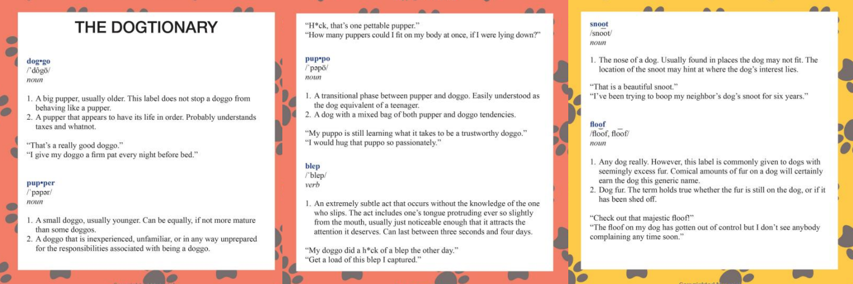

### What is the average rating per dog stage?

Here I wanted to vizualise the average rating per dog stage as shown above and the results are very interesting. Although the rating denominator is 10, in average most of the dogs in the different stages have above that rating.